Components
• Components are the building blocks of any React app.
• Components let you split the UI into independent, reusable pieces, and think about each piece in isolation.
• Components are like JavaScript functions. They accept arbitrary inputs (called “props”) and return React elements describing what should appear on the screen.
• Always start component names with a capital letter.
• React treats components starting with lowercase letters as DOM tags. For example,
<div /> represents an HTML div tag, but <App /> represents a component requires App to be in scope

Function Components
It is a JavaScript function which accepts a single “props” object argument with data and returns a React Element.
Syntax:-
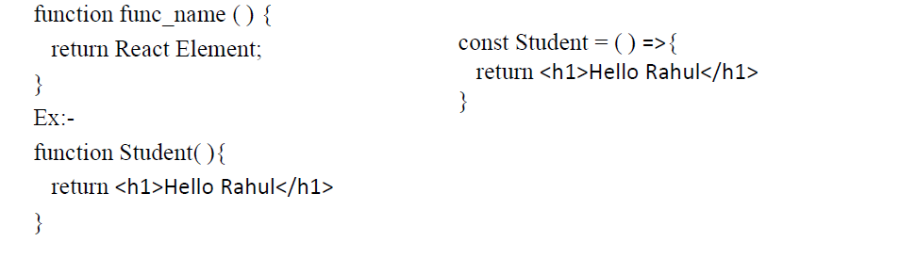
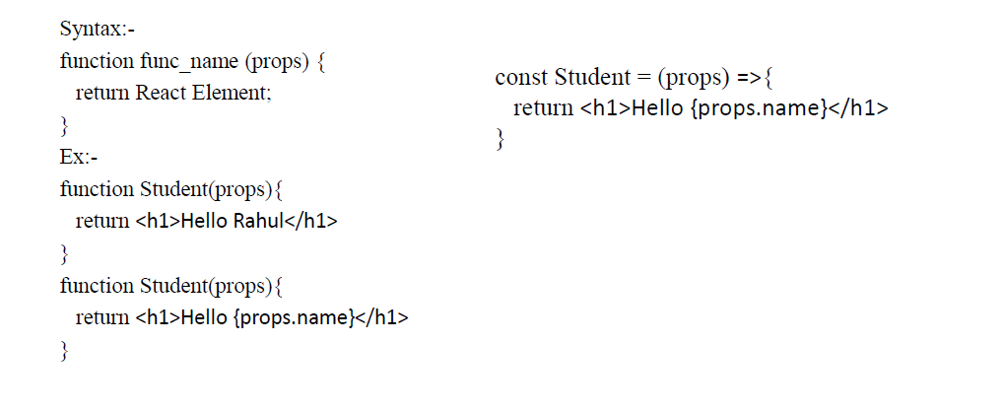

Class Component
A class component requires you to extend from React.Component. The class must implement a
render() member function which returns a React component to be rendered, similar to a return
value of a functional component. In a class-based component, props are accessible via this.props.
Syntax:-
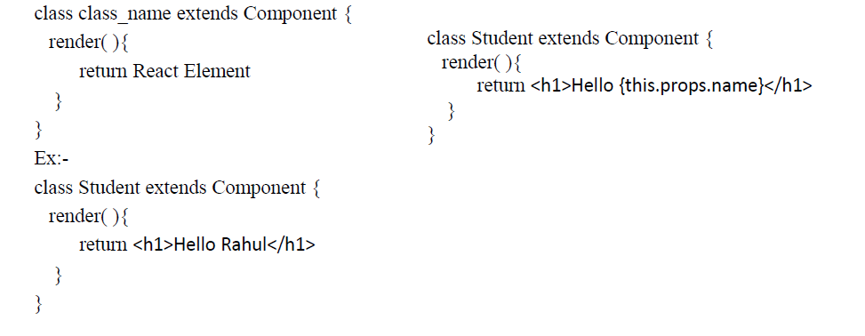
Rendering a Component
ReactDOM.render(<Student />, document.getElementById(“root”));
ReactDOM.render(<Student name=“Rahul”/>, document.getElementById(“root”));
Ex:-
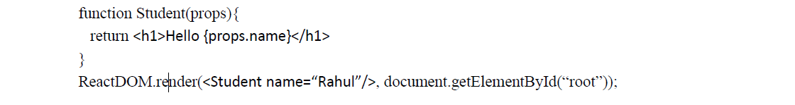
When React sees an element representing a user-defined component, it passes JSX attributes to
this component as a single object. We call this object “props”.
Composing Components
Components can refer to other components in their output. This lets us use the same component abstraction for any level of detail.
Ex:-
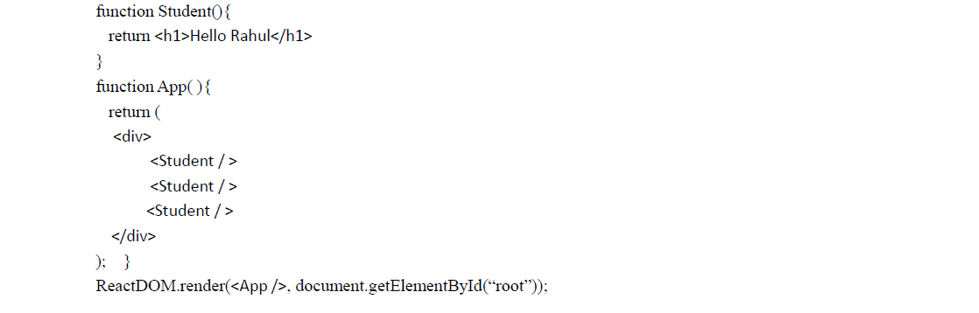

Functional vs Class Component
Use functional components if you are writing a presentational component
which doesn’t have its own state or needs to access a lifecycle hook. You
cannot use setState() in your component because Functional Components are
plain JavaScript functions,

Use class Components if you need state or need to access lifecycle hook
because all lifecycle hooks are coming from the React.Component which you
extend from in class components.

JavaScript XML (JSX)
JSX stands for JavaScript XML. It is a syntax extension to JavaScript.
JSX is a preprocessor step that adds XML syntax to JavaScript.
JSX produces React “elements”. It is possible to create element without JSX but JSX
makes React a lot more elegant.
It is recommended to use JSX with React to describe what the UI should look like.
JSX is easier to read and write. Babel transform these expressions into a actual
JavaScript Code.
It also allows React to show more useful error and warning messages.

